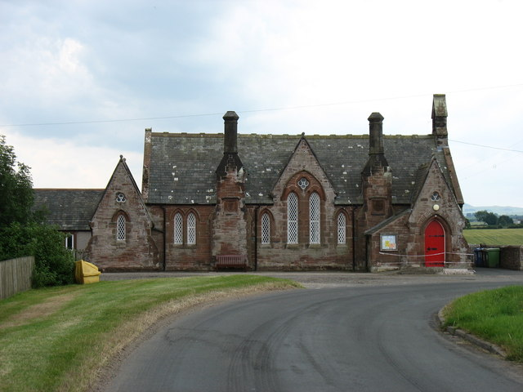

BLENCOGO & DISTRICT VILLAGE HALL PRODUCE SHOW
To be held in the Blencogo Village Hall on Saturday 7th September 2019
Entry is open to all. Entries on the day. Entry fee 30p per item, children classes are now 20p per item
Admission 50p School children free. Refreshments available.
10am -11.30: Staging 11.30-1.45pm Hall closed for Judging
2pm Hall opens to public.
3.30pm Presentation of Trophies.
Auction of produce. Followed by distribution of prize money.
Prizes 1st £1.50 2nd £1 3rd 50p
Points:1st = 3 points 2nd =2 points 3rd =1 point.
Trophies will be awarded to the person gaining most points in the following sections.
Bromfield Parish cup for flowers.
H. Douglas Fuchsia Plaque.
Tom Carrick Cup for Kitchen Garden.
Ferguson Salver for Bakery.
St Mungo’s Cup for Handicrafts.
Blencogo Village hall Children’s Trophy for 8yrs and over.
New this year Alfred Greive trophy for children 7 years and under.
High Aketon Trophy for most points in show.
Any schedule queries to Linda on 07538027936 or Judith 61051.
Please have a go – support your local show.

Rules:
- All exhibits must be the work of the exhibitor.
- No exhibit allowed that has previously won a prize.
- Handicrafts to have been made in the last 3 years.
- Exhibits to be staged between 10am and 11.30 and may not be removed until 3.40pm when any produce remaining will be auctioned.
- Labels must be collected on arrival and attached to the exhibit by the exhibitor.
- Exhibitors to provide own vases etc.
- 1 Entry per class per person.
- No one will be allowed in the hall during the judging except the organizing committee.
- Entry fee is 30p per item, children’s classes 20p.
- Prizes: 1st - £1.50, 2nd - £1, 3rd – 50p. No prizes will be awarded unless entries are of sufficient merit.
- The committee cannot hold itself responsible for loss or damage to exhibits or containers.
- The decision of the judge is final.
- If any entry is submitted, it is presumed that the entrant agrees to the foregoing rules.
- Children’s ages to be shown.

Flowers
1. Fuchsia Pot Plant.
2. Fern in a pot.
3. A single stem of any flower.
4. A rose.
5. Vase of sweet Peas.
6. 3 Dahlias.
7. Cut Gladiola’s.
8.Bowl of Marigolds
9. Display” Walk in the woods” (using foliage, berries, cones, driftwood no flowers.
10. Vase of mixed Garden Flowers.

Kitchen Garden
11. Four fresh herbs in a tumbler
12. 3 free range eggs (one egg cracked into a saucer) (laid from own chickens)
13. 3 onions.
14. 4 Potatoes.
15. Any other single vegetable not in the schedule.
16. 3 Carrots.
17. 4 Tomatoes - any variety.
18. 4 Cherry Tomatoes
19. 5 Green Beans.
20. 3 Beetroot.
21. Selection of Home-grown fruit in a bowl (not exceeding7 pieces).
22. 3 Courgettes.
Wine/ Liqueur 23. Bottle of Red Wine 24. Bottle of White Wine.
Bakery
25.Men only cake of own choice.
26. Malted milk cake. (using Mary Berry’s recipe)
27. 3 Millionaire Shortbread.
28.Ginger loaf.
29. Traditional swiss jam roll.
30. Saucer fruit pie (short crust pastry).
31. 3 bread rolls.
32. 3 unusual flavoured Scones (label).
33. Homemade Chutney. (label)
34. Jar of Jam (label)
35. Jar of Marmalade.
36. Jar of Honey

Handicrafts
37. Photo with own caption no larger than 8"x 6".
38. Photo of a garden visitor.
39.Lavender bag not exceeding 20cm.
40. Crochet work (any yarn).
41. Handmade wooden item.
42.Painting in watercolours any subject.
43. Homemade decorated box.
44. Any article made by Lady or Gent.
45. Pick up and bring a doorstop

Children (must display age)
Under 7 and including 7 years.
46. 2 Decorated digestive biscuits.
47. Model of a sheep made with cotton balls.
48. Handwrite a short extract from Peter Rabbit.
49. Painted handprint (decorated)
50. Make model (not a kit) any material e.g. Plasticine, play-doh.

8 years and over.
51. 3 Butterfly Buns.
52.Make a paier mache bowl and decorate.
53. Handwrite your favourite poem.
54.A collage picture using dried pasta, seeds & pulses.
55. Pick up and bring a snow globe.

